Quick Trip Competition
(rule version 20180130.03)

Objective: The robot will travel between two zones that are approximately 12 feet apart, making a round trip from one zone to the other and returning to the first zone. The robot must come to a complete stop at the end of both legs of its journey. A lane between the two zones is defined and the robot’s travel must remain within the lane’s boundaries. In the start and ending zones a space of 6 inches is marked that represents the center of the starting zone. Additional consideration is given to robots that place their center inside of the 6-inch space in each zone while they are stopped in a zone.

Robot: Competing robots must run autonomously but are not required to be self-contained. Robot size is limited to 18x18 inches. Maximum robot weight is 30 pounds.

Self-Contained Definition: Self-contained means that all computing power used to run the robot is carried on the robot platform.

Run Definition: A run starts when the robot is placed in the starting area of the arena, given a signal from the judge, and moves. If the robot fails to move, the competitor can remove the robot and try again at the end of the round. If the robot doesn’t move when given this 2nd chance, its run is forfeited. The run ends whenever the robot completes the objectives, or malfunctions after moving, or 3 minutes has elapsed. Each robot is allowed 1 run per contest round.

Round Definition: A round consists of a single run by each competing robot. The competition consists of 3 rounds.

Play: At the start of the competition, the robot may be placed anywhere in the start zone. The robot may be turned to any angle when initially placed.

The robot must travel from the starting zone to the opposing zone, come to a complete stop, then travel back to the starting zone and come to a complete stop.

A robot must be completely in a zone to be considered to have travelled to that zone.

Competitors can setup beacons or other navigational aids outside of the arena along the longer sides of the arena lane, but not in the shorter sides of the arena or along the sides of the end zones.

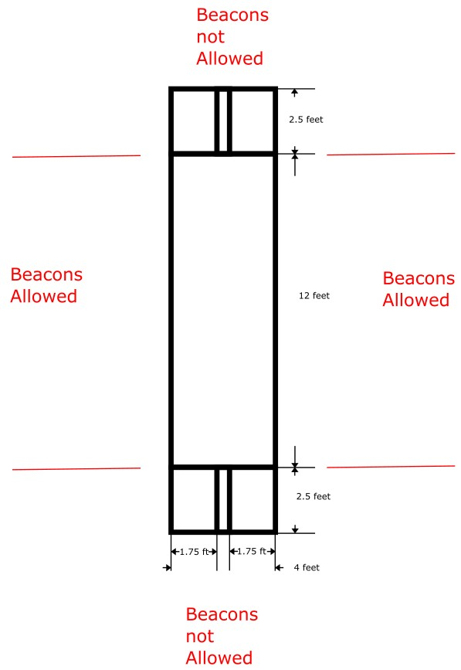

Course: The total course size is 4x17 feet. The course surface may either be the flooring of the room used for the competition, or a temporary material such as a white vinyl mat. If the flooring of the room is used, all arena markings will be made using ¾ inch blue tape. If a white vinyl mat is used, the markings will be ¾ inch blue or black lines.
The two end zones are 2.5x4 feet with the center 6 inches along the 4-foot dimension marked.
The two end zones are separated by a 4x12 lane.

Scoring: A robot’s run score is the sum of the number of objectives scored. A point is scored for each objective completed. The top three scores will be awarded 1st, 2nd, and 3rd place in the competition. Where scores are the same, the fastest run time will be used to determine the winner. The objectives are:
- Reach the opposing end zone.
- Stop in the opposing end zone.
- Have the center of the robot within the 6-inch marked area of the end zone.
- Return to the starting zone.
- Stop in the start zone.
- Have the center of the robot within the 6-inch marked area of the start zone.
- Stay within the boundaries of the arena lane.

A perfect score is 7.

Judging: One or more judges will referee the contest. They will ensure the rules are followed and impose scoring penalties or remove a robot from competition if the robot is operating in an unsafe manner or not complying with the rules. The decisions of the judges are final.

Safety: If the behavior of a robot is determined to be unsafe, the judge will withdraw the robot from the competition. The decisions of the judges regarding safety matters are final.

